(For students who are using with a counselor)
EVERFI Student Registration Guide

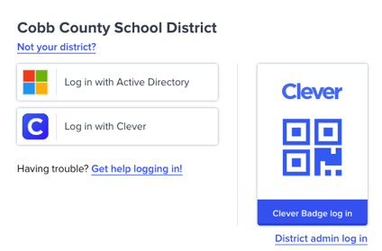
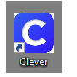
Go to www.clever.com

- Click Login and search for your school
- Login with the “active directory” one of 2 ways
- Use Office 365 Login -
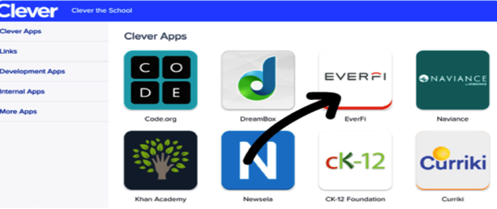
Username: first name.lastname
Password: computer password at school
- Search for the EVERFI tile in your list of apps:

Make sure you are working in the “CURRENT COURSES TAB” (Not remote learning)
Enter your registration code on the top right corner: Use Code emailed by your teacher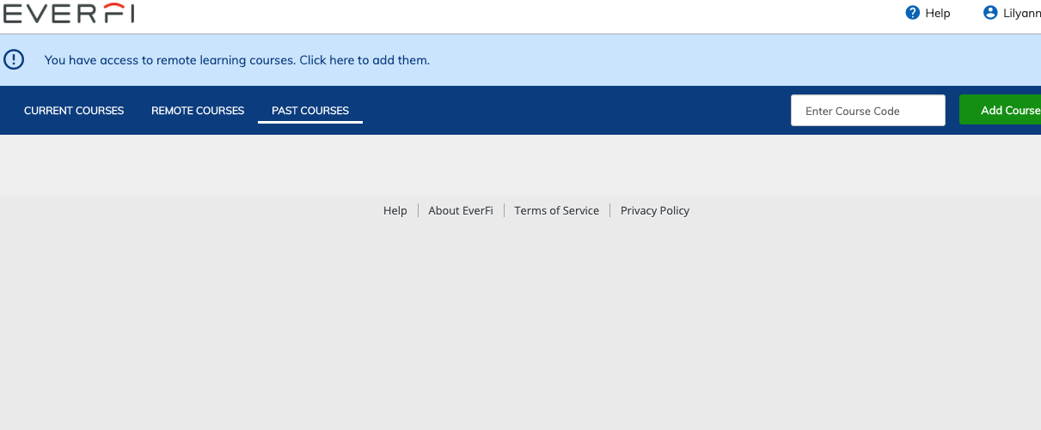

- Confirm you are “under 13”
Look for tile for “Compassion Project” titled: (3-5) Mrs. Hatcher Counseling
- Click get started
- If you see an error screen, exit out and re-enter through the EVERFI tile.
**Please use Chrome as your internet browser**

