Welcome Back from Mrs. Kelley! | 8-11-20
Mrs. jessie Kelley  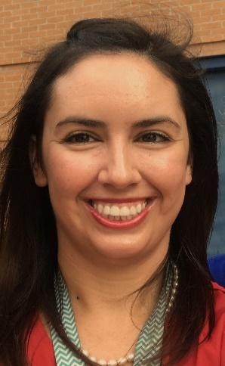  I will be working with grades 1st, 4th, and 5th. This is my 2nd year at King Springs, and 6th year as a school counselor. I am originally from Fayette County, GA and a proud graduate of GA Southern University! I live with my husband and enjoy travelling, going to the beach, working out at HotWorx, and relaxing with Netflix and Amazon Prime!  school counseling blog  https://kingspringscounselors.weebly.com/  Includes outside resources and support for students and families, including during digital learning.  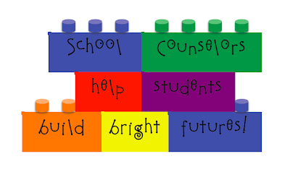  One Team, One Goal, Student Success  Our staff has been working very hard these past few weeks and know that virtual learning will bring its own challenges, but let’s all work together as a KSE family to support our students in ways that will challenge, inspire, and motivate them to achieve success. We want to sincerely thank you for all you have done and will continue to do for our students!  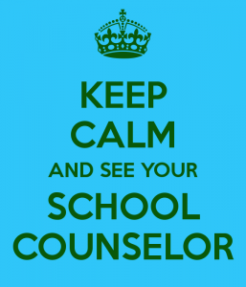  Jessie Kelley, 1st, 4th, 5th School Counselor, Jessica.Kelley@cobbk12.org | Counseling services provided  Counseling Lessons: I will teach each classroom once every 2 weeks. Lessons will focus on helping students achieve success in school and out of school. Topics may include but aren’t limited to friendship, showing respect, problem-solving, handling conflict, growth mindset, and responsibility.  Small Groups: School counselors provide small groups as determined by school needs. Topics might include how to make friends, study skills, how to deal with family change, coping skills, loss, self-esteem, self-control, or managing emotions. Small groups are an opportunity for students to connect with each other and work towards a common goal.  Individual Counseling: I will provide individual counseling upon request and as needed. Our goal as school counselors is help students use and develop their strengths to become the best student and person they can be. If you have a concern or any questions about your child, the best way to reach me is via email at Jessica.Kelley@cobbk12.org.  Standards for School Counselors and Students  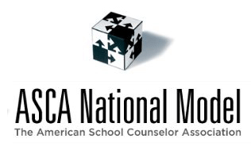  KSE School Counseling Mission and Vision:  Vision: To develop the foundation for students to become productive, contributing members of an ever-changing global society. To develop learners who are not afraid to make mistakes in the pursuit of academic and personal growth. To inspire young hearts to seek a world that is filled with kindness and compassion.  Mission: In partnership with the community, we will develop our students’ excellence in academic, personal/social and career development. Counseling services will be proactive, comprehensive, and data-driven. The program will empower and motivate students to seek high achievement both inside and outside the classroom and beyond.

